**CREDITCARDFRAUDDETECTION**

**PROBLEM DEFINITION :**

**The process of automatically differentiating between fraudulent and genuine users is known as “credit card fraud detection”.**

The problem is to develop a machine learning-based system for real-time credit card fraud detection. The goal is to create a solution that can accurately identify fraudulent transactions while minimizing false positives . This project involves data preprocessing, feature engineering, model selection, training, and evaluation to create a robust fraud detection system.

**DESIGN THINKING :**

* **DATASOURCE** : Utilize a dataset containing transaction data, including features such as transaction amount, timestamp, merchant information, and card details.
* **DATAPREPROCESSING** : Clean and preprocess the data, handle missing values, and normalize features.

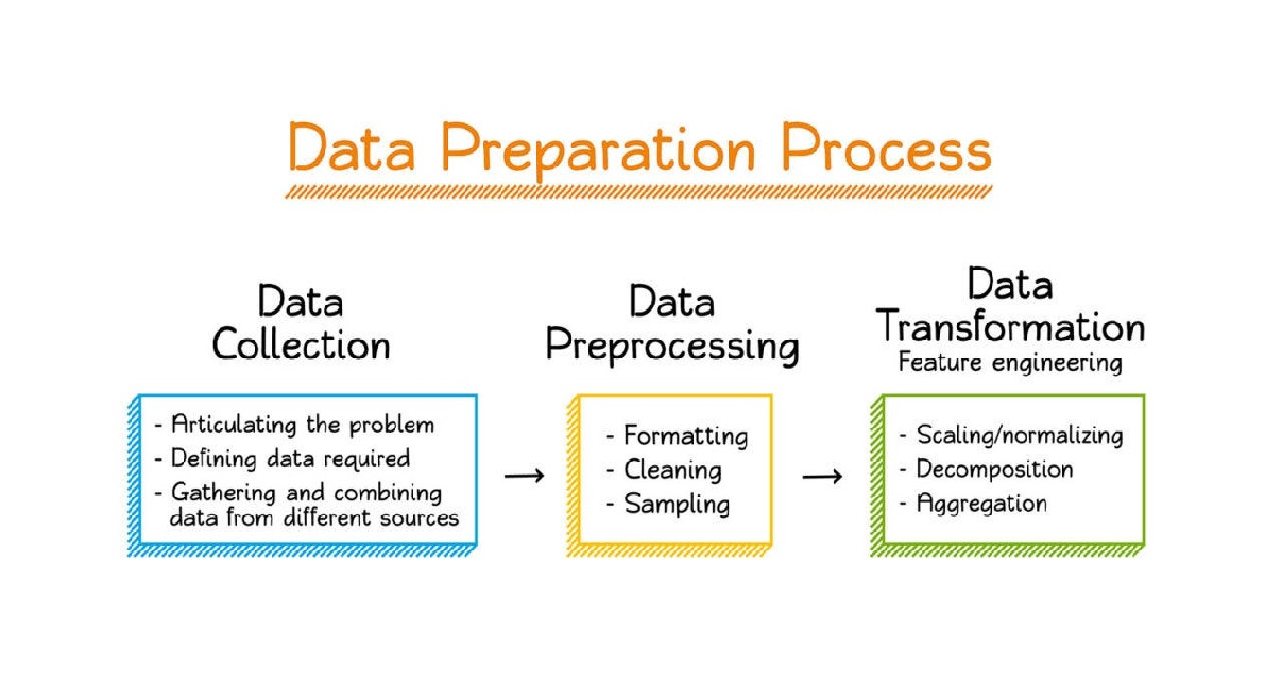

● **FEATURE ENGINEERING :** Create additional features that could enhance fraud detection,such as transaction frequency and amount deviations



* **MODELSELECTION** : We will be choosing suitable machine

learning algorithms to predict modelling problem (Credit card fraud detection) . The Techniques / algorithms

for fraud detection can be the following :

* 1. Logistic Regression
  2. Random Forest
  3. Gradient Boosting
* **MODELTRAINING:** This step is to train the selected model using the preprocessed data.
* **EVALUATION** : The final step is to evaluate the model's

performance using metrics like accuracy, precision, recall, F1-score, and ROC-AUC.

**DATASETLINK :**

[**https://www.kaggle.com/datasets/mlg-ulb/creditcardfraud**](https://www.kaggle.com/datasets/mlg-ulb/creditcardfraud)

**CONCLUSION :**

Thus , the problem is to develop a machine learning-based system for real-time credit card fraud detection done by using a suitable algorithm which involves data preprocessing, feature engineering, model selection, training, and evaluation to create a robust fraud detection system.